**Economical classification of countries: a world bank study**

World Bank categorizes countries based on various characteristics, such as geography, lending eligibility, fragility, and average level of income, to help shed light how different groups of countries are doing. When it comes to income , the World Bank divides the world's economies into four income groups:  high, upper-middle, lower-middle, and low.

The income classification is based on a measure of national income per person, or GNI per capita, calculated using the Atlas method.

**Data Source:**

<https://data.worldbank.org/indicator/SP.POP.TOTL?locations=MX-AF-BD>

<https://datahelpdesk.worldbank.org/knowledgebase/articles/898590-country-api-queries>

**Visualizations:**

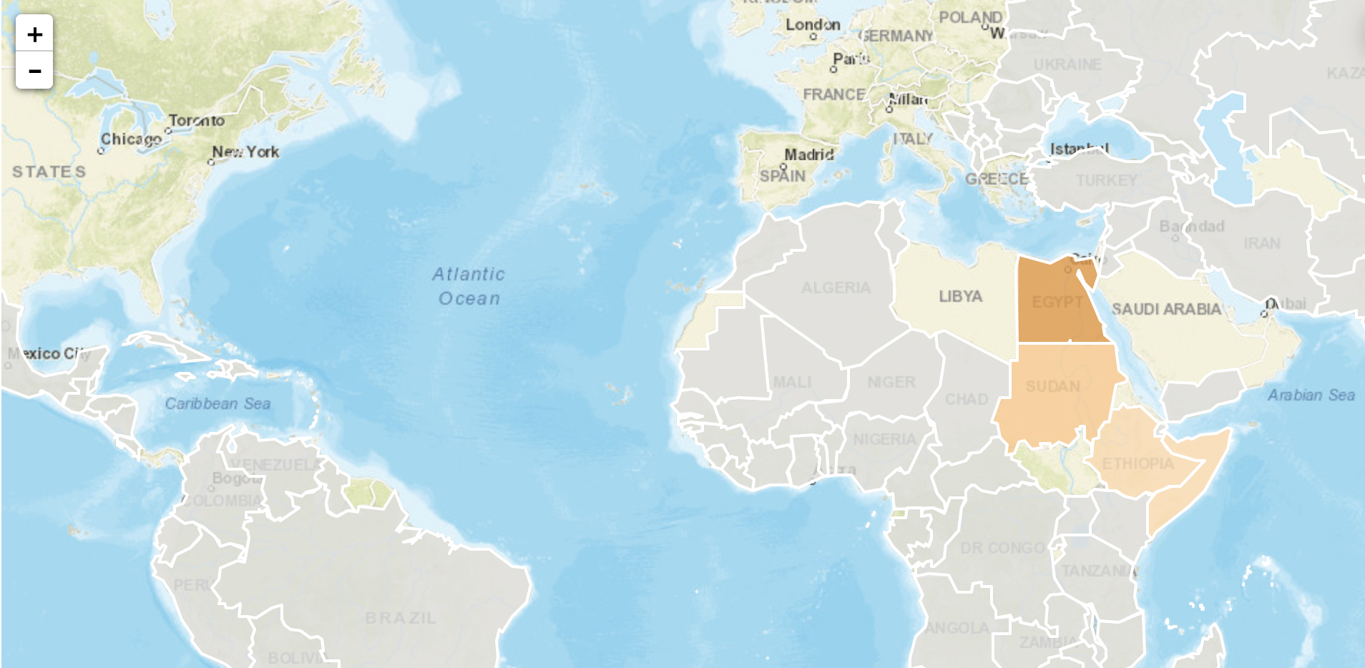

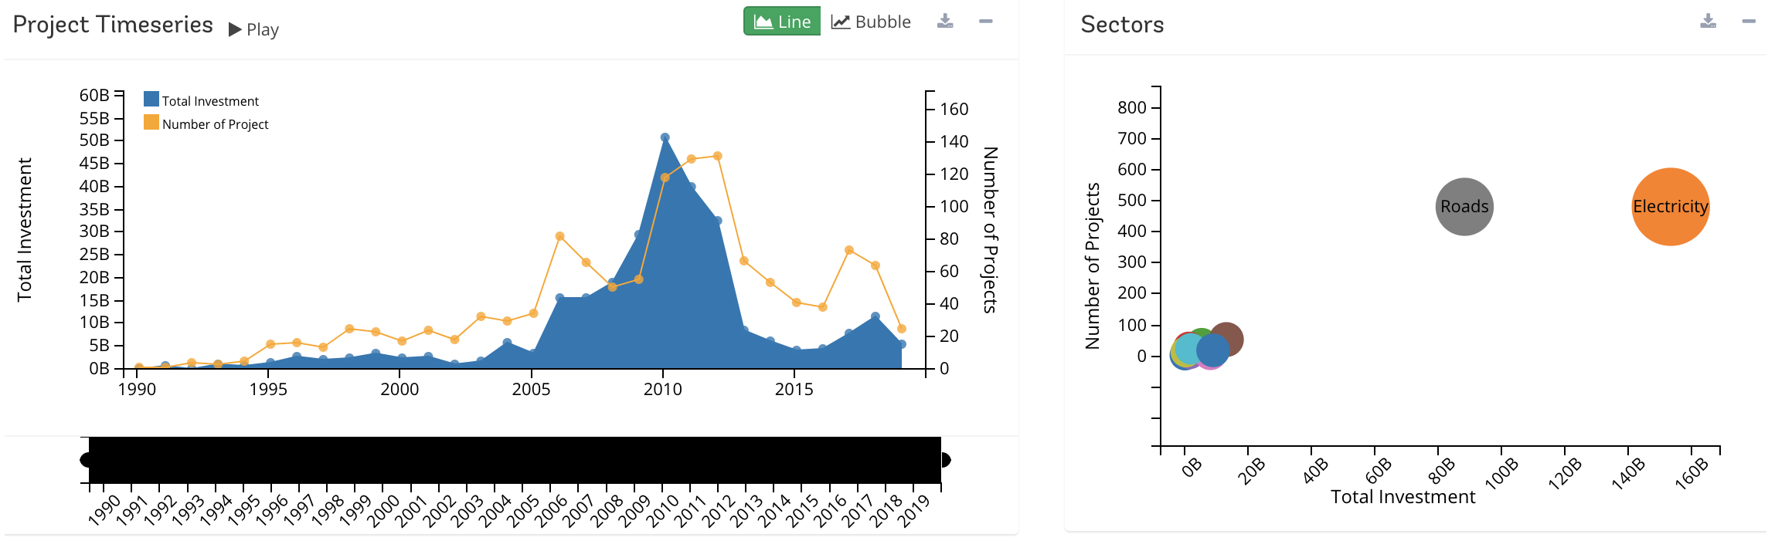

**Layout:**

**Technology used: Flask, D3,HTML,css,javascript,MongoDB,Leaflet**



**GitHub Link:**